Name of Company that employs you
Address

Attention: Name

Dear Employer

REQUIREMENT TO TAKE THE COVID 19 VACCINE

- Thank you for your letter or notice dated date informing me that you direct me, as my employer, to have the COVID-19 "Vaccine" ("mRNA Injection").

Potential Personal Grievance

- I must inform you that I may file a personal grievance under the following sections Employment Relations Act 2000 ("ERA”):

103 (1) For the purposes of this Act, personal grievance means any grievance that an employee may have against the employee's employer or former employer because of a claim—

(b) - that the employee's employment, or 1 or more conditions of the employee's employment (including any condition that survives termination of the employment), is or are or was (during employment that has since been terminated) affected to the employee's disadvantage by some unjustifiable action by the employer;

(j)(ii) - that the employee's employer has, in relation to the employee,—
(ii) contravened section 92 of the Health and Safety at Work Act 2015 (which prohibits coercion or inducement).

- For your information, section 92 of the Health and Safety at Work Act 2015 ("HSWA") states

Prohibition on coercion or inducement

- A person must not organise or take, or threaten to organise or take, any action against another person with intent to coerce or induce the other person, or a third person:

- to perform or not to perform, or to propose to perform or not to perform, a function under this Act or a function under this Act in a particular way; or

- to exercise or not to exercise, or propose to exercise or not to exercise, a power under this Act or a power under this Act in a particular way; or

(c) to refrain from seeking, or continuing to undertake, a role under this Act.

- Under the HSWA, if a potential risk is identified to the Person Conducting a Business or Undertaking, you must assess that potential risk to make sure it cannot adversely affect the health and safety of employees and have the appropriate policies, procedures, and resources in place and to the monitor the risk.

Questions

- We know that once you have been vaccinated, you cannot undo the vaccine. Consequently, as you wish to coerce me into taking the mRNA Injection as a new term of employment which I did not agree to, I would like answers to the following questions:

Q1: Please refer me to the policy, which requires employees to participate in a clinical trial?

- Please note that the mRNA Injection is currently being administered on provisional licences as part of a two-year trial which will not be completed until 2023.

Q2: What health and safety risk identification, mitigation and review will you be undertaking?

- Please provide me with copies of the information.

Q3: Will the mRNA injection prevent or reduce transmission of COVID-19? If not, why do you require me to participate in a clinical trial of an experimental medical treatment as a term of my employment?

- Please note that Medsafe's position as of August 2021:

- The Pfizer `Fact Sheet for Recipients and Care Givers' (Pfizer Fact Sheet) states that:

"The Pfizer-BioNTech COVID vaccine is an unapproved vaccine that may prevent COVID. There is no FDA-approved vaccine to prevent COVID."

"[t]he duration of protection against COVID is currently unknown."

- We noted with interest that Merck discontinued the development of the vaccine as it found that:

"…the immune responses were inferior to those seen following natural infection and those reported for other SARS-CoV-2/COVID vaccines."

- In addition, Dr Anthony Fauci, the director of the U.S. National Institute of Allergy and Infectious Diseases and the chief medical advisor to the president, has confirmed that the mRNA Injection aims to prevent some milder symptoms of Covid-19 rather than preventing transmission in a recent interview.

Q4: Will the mRNA Injection reduce serious illness if I contract COVID-19? If not, why do you require me to participate in a clinical trial of an experimental medical treatment as a term of my employment?

- Peter Doshi's reported in the British Medical Journal that the Covid 19 mRNA Injection trial had not been set up to detect if there will be a reduction in any serious outcomes from Covid 19 or whether the mRNA Injection has interrupt transmission of the disease.

- The research to determine whether the mRNA Injection has any effect in reducing hospital admissions has not commenced. However, Kaiser Permanente Southern California is about to commence "Pfizer-BioNTech COVID BNT162b2 mRNA Injection Effectiveness Study" to determine the mRNA Injection effectiveness (VE) of 2-doses of Pfizer's BNT162b2 mRNA Injection against COVID-associated hospitalisation.

- I understand that Pfizer's only concern is whether the mRNA vaccine would reduce mild symptoms.

- A recent peer-reviewed article, Informed consent disclosure to vaccine trial subjects of risk of COVID-19 vaccines worsening clinical disease, by Dr Timothy Cardozo (MD, PhD) and Professor Ronald Veazey undertook a study was to determine if sufficient literature exists to require clinicians to disclose the specific risk that COVID-19 vaccines could worsen disease upon exposure to challenge or circulating virus. The study found:

“COVID-19 vaccines designed to elicit neutralising antibodies may sensitise vaccine recipients to more severe disease than if they were not vaccinated. Vaccines for SARS, MERS and RSV have never been approved, and the data generated in the development and testing of these vaccines suggest a serious mechanistic concern: that vaccines designed empirically using the traditional approach (consisting of the unmodified or minimally modified coronavirus viral spike to elicit neutralising antibodies), be they composed of protein, viral vector, DNA or RNA and irrespective of delivery method, may worsen COVID-19 disease via antibody-dependent enhancement (ADE). This risk is sufficiently obscured in clinical trial protocols and consent forms for ongoing COVID-19 vaccine trials that adequate patient comprehension of this risk is unlikely to occur, obviating truly informed consent by subjects
in these trials.”

“Conclusions drawn from the study and clinical implications. The specific and significant COVID-19 risk of ADE should have been and should be
prominently and independently disclosed to research subjects currently in vaccine trials, as well as those being recruited for the trials and future patients after vaccine approval, in order to meet the medical ethics standard of patient comprehension for informed consent.”

Q5: Does the mRNA Injection have full consent? If not, why do you require me to take an irreversible experimental medical treatment which has not been granted full consent as a term of my employment?

- Medsafe’s website states the following:
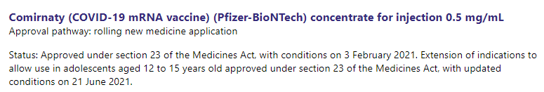

- Section 23(1) of the Medicines Act states:
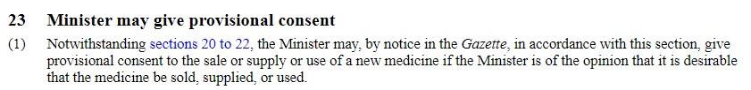

Q6: Was the normal vaccine development protocol followed? If not, why do you require me to take an irreversible experimental medical treatment with no medium or long term safety data as a term of my employment?

- Vaccine development is usually a slow and laborious process that takes between 5 to 10 years. However, the co-founder of BioNTech designed the coronavirus vaccine it made with Pfizer in just a few hours over a single day.

- Eminent vaccine authority Dr Peter Hotez, dean of the National School of Tropical Medicine at Baylor College of Medicine, who was involved in developing a potential SARS (a type of coronavirus) vaccine, has issued stark warnings regarding the way the current Covid vaccines have been developed.

- Dr Peter Hotez stated:
"I understand the importance of accelerating timelines for vaccines in general, but from everything I know, this is not the vaccine to be doing it with.”

- The speed at which the mRNA Injection has been rolled out is unprecedented. However, no matter what we are told about safety, Pfizer has not done all the tests that they would normally undertake to develop a vaccine. There is no way that Pfizer could have undertaken all the tests that would typically be undertaken in the 5 to 10 years in approximately seven months. Therefore, there is no medium or long-term data about the safety of the mRNA Injection.

- The safety data is simply not there.

Q7: Please could you provide me with a copy of the benefit and risk assessment undertaken by Medsafe as part of the Pfizer/Biotech provisional consent? If you cannot provide me with a copy of this information, please let me know what benefit and risk assessments you have undertaken to ensure that I do not suffer harm?

- A request for official information was made in March 2021 under the Official Information Act, asking for details of the benefit and risk assessment undertaken as part of the Pfizer/Biotech vaccine approval. However, the New Zealand Ministry of Health elected to withhold the information as per a copy of the letter set out below:
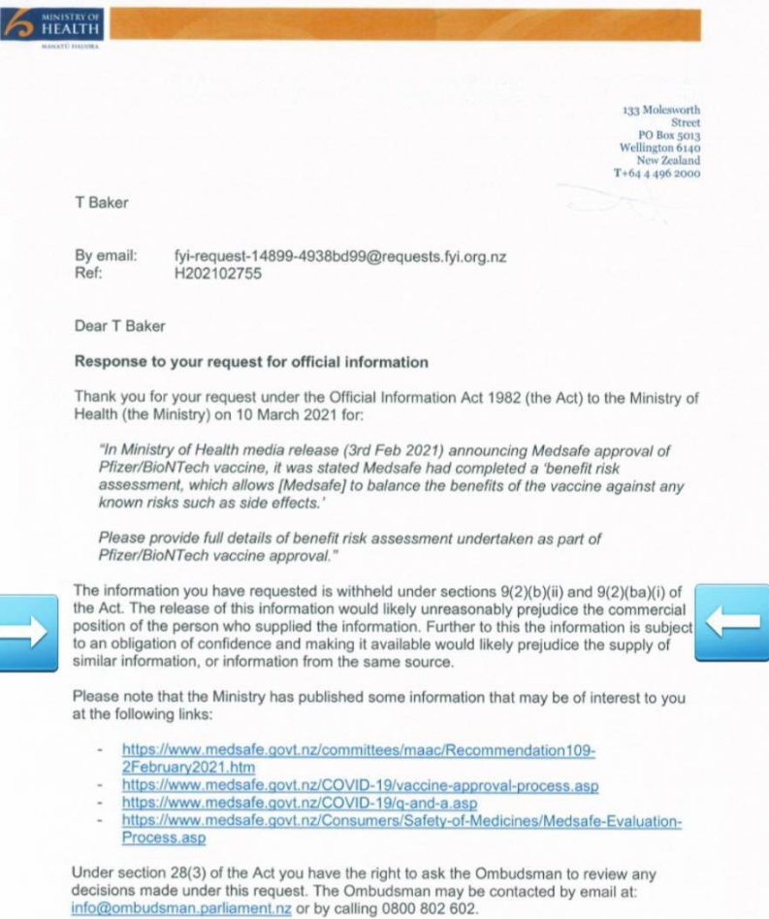

Q8: Should I be concerned that the preliminary vaccine trials did not include research on the impact of the vaccine on the elderly, the immune-compromised, pregnant women, and different ethnic groups, nor were the trials designed to look at whether the mRNA Injection reduces serious outcomes? Do you know if I fit into one of these categories that has not been the subject of research?

- Individuals have different physiologies and what may be harmless to one individual is potentially lethal to another (e.g., peanut and egg allergies are examples).

- The "Summary of the risk management plan for Comirnaty (COVID-19 mRNA vaccine)"? published on MedSafe's website sets out the "Important Risks and Missing Information table":

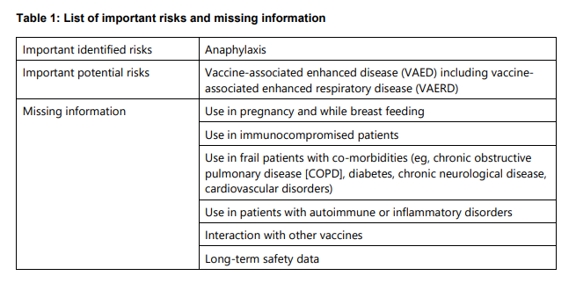

Q9: Should I be concerned about the Animal Studies from Previous Coronavirus Vaccines? If not, please could you explain why I should not be concerned?

- I want to emphasise that this medical treatment is not like other vaccinations that the Ministry of Health has administered in the past. This is a clinical trial for a synthetic gene therapy never used to help prevent infection from a virus. It is a different technology than the traditional Attenuated Virus vaccines that we are used to.

- According to America's Front-Line Doctors, `White Paper on Experimental mRNA Injection for Covid 19':

"vaccine safety requires proper animal trials and peer-reviewed data, neither of which has occurred during operation warp speed. This is especially concerning considering the fatal failure of prior coronavirus vaccine attempts such as SARS-CoV-1, the virus that is 78% identical to SARS-CoV-2 (COVID)."

- However, given the perceived urgency, vaccine makers moved straight into small-scale human tests without waiting to complete such animal tests.

- Dr Peter Hotez worked on developing a vaccine for SARS, the coronavirus behind a major 2003 outbreak, and found that some vaccinated animals developed more severe diseases compared with unvaccinated animals when they were exposed to the virus. Peter Hotez spoke to Reuters in 2020 and stated that

"There is a risk of immune enhancement …the way you reduce that risk is first you show it does not occur in laboratory animals."

- Scientists are concerned about when the previous mRNA vaccines were tested on animals. While the animals seemed fine at first when they were exposed to the actual virus, their bodies overreacted, and many of the animals died.

https://journals.plos.org/plosone/article?id=10.1371/journal.pone.0035421
https://www.jstage.jst.go.jp/article/jvms/60/1/60_1_49/_article
https://pubmed.ncbi.nlm.nih.gov/22536382/
https://pubmed.ncbi.nlm.nih.gov/17194199/
https://pubmed.ncbi.nlm.nih.gov/18941225/

Q10: Should I be concerned about taking the mRNA Injection if I am pregnant? Do you know if I am pregnant? Are you allowed to ask me if I am pregnant under employment law?

- A study published in the New England Journal of Medicine of COVID19 vaccinations given to pregnant women (mainly in their 3rd trimester) shows that approximately 14% of them resulted in pregnancy loss.

"Among 3958 participants enrolled in the v-safe pregnancy registry, 827 had a completed pregnancy, of which 115 (13.9%) resulted in a pregnancy loss and 712 (86.1%) resulted in a live birth (mostly among participants with vaccination in the third trimester). Adverse neonatal outcomes included preterm birth (in 9.4%) and small size for gestational age (in 3.2%); no neonatal deaths were reported. Although not directly comparable, calculated proportions of adverse pregnancy and neonatal outcomes in persons vaccinated against Covid-19 who had a completed pregnancy were similar to incidences reported in studies involving pregnant women that were conducted before the Covid-19 pandemic. Among 221 pregnancy-related adverse events reported to the VAERS, the most frequently reported event was spontaneous abortion (46 cases)”.

- According to the CDC, Clinical trials for the COVID-19 vaccines currently authorised for use under an Emergency Use Authorization in the United States did not include breastfeeding people. Because the vaccines have not been studied on lactating people, there are no data available on the:

- Safety of COVID-19 vaccines in lactating people
- Effects of vaccination on the breastfed baby
- Effects on milk production or excretion

- In addition, no single-dose toxicity studies, toxicokinetic studies, genotoxicity or carcinogenicity studies were conducted. Nor were there any studies on when couples receive the mRNA Injection and the impact on future children.

Q11: What are the risks of `viral immune escape' from the mRNA Injection? If you do not know the risks, why do you require me to take an experimental medical treatment that could harm me, other employees and third parties?

- Dr Geert Vanden Bossche, a vaccine maker, in his open letter to the World Health Organisation (WHO), raised the issue of the covid vaccines and the detrimental consequences of further 'viral immune escape'.

Dr Geert Vanden Bossche: Dr. Geert Vanden Bossche phD, DVM is a world-renowned vaccine developer, headed projects for Glaxo-Smithkline and Novartis, worked for the Bill & Melinda Gates Foundation and GAVI, was Head of the mRNA Injection Development Office for the German Centre for Infection Research (DZIF) and had a vaccine consultancy business from 2012 to 2019. He also represented GAVI in fora with other partners, including WHO, to review progress on the fight against Ebola and to build plans for global pandemic preparedness.

- Professor Luc Montagnier, a French virologist and recipient of the 2008 Nobel Prize in Medicine, discovered the human immunodeficiency virus (HIV). He contends that “it is the vaccination that is creating the variants”.

- This idea is not new, as this paper was published in PLOS BIOLOGY in 2015.

Imperfect Vaccination Can Enhance the Transmission of Highly Virulent Pathogens (nih.gov)

Q12: What is the risk of the `spike protein' to my health? If you do not know the risks, why do you require me to take an experimental medical treatment that could harm me, other employees and third parties?

- Pfizer's website states that the mRNA Injection works by:

"mRNA, delivered to your body's cells by lipid nanoparticles, instructs the cells to generate the spike protein found on the surface of the novel coronavirus that initiates infection.1,2 Instructing cells to generate the spike protein spurs an immune response, including generation of antibodies specific to the SARS-CoV-2 spike protein."

- Many doctors and scientists have pointed out that contrary to what the Government states about safety, the spike protein induced by the vaccine does not remain only in the muscle around the vaccination site but gets absorbed and circulates in the bloodstream and to various vital organs of the body

- Dr Robert Malone is speaking out as he and other scientists did not expect the Spike Protein from the vaccine to move from the muscle in the arm from where it was injected and travel to other parts of the body, causing harm. Dr Robert Malone believes the Spike Protein could reach the bone marrow and lead to people developing leukaemia (Blood Cancer) - only time will tell.

Dr Robert Malone The inventor of mRNA vaccines and one of the world’s foremost experts on messenger mRNA therapeutics - having invented the field in 1988, Dr Malone has extensive research and development experience in the areas of pre-clinical discovery research, clinical trials, vaccines, gene therapy, biodefense, and immunology. He has over twenty years of management and leadership experience in academia, pharmaceutical and biotechnology industries, as well as in governmental and non-governmental organisations.

- Dr Yeadon (former Vice President Respiratory & Chief Scientific Advisor, Pfizer – full CV summary set out above) and Dr Wodarg (lung specialist and former head of the public health department) filed an application with the European Medicine Agency (EMA) for the immediate suspension of all SARS CoV2 vaccine studies, in particular the BioNtech/Pfizer study on BNT162b (EudraCT number 2020-002641-42). A pdf copy of the letter can be accessed by clicking on the link below:

https://dryburgh.com/wp content/uploads/2020/12/Wodarg_Yeadon_EMA_Petition_Pfizer_Trial_FINAL_01DEC2020_signed_with_Exhibits_geschwarzt.pdf
- Dr Yeadon has explained in laypersons terms that when you administer a substance to a person, you want to know where the substances distribute to in the body, how long it stays there (Pharmacogenetics), and what does it do when it is there (Pharmacodynamics). According to Dr Yeadon, the vaccine manufacturers are not required to study either. Accordingly, they do not have to study where the spike protein goes, what it does and for how long.

- Dr Byram Bridle, a viral immunologist and associate professor at the University of Guelph, Ontario, in an interview, warned listeners that his message was “scary.” Dr Byram Bridle stated that:

“We thought the spike protein was a great target antigen, we never knew the spike protein itself was a toxin and was a pathogenic protein. So by vaccinating people we are inadvertently inoculating them with a toxin …”
“We have known for a long time that the spike protein is a pathogenic protein. It is a toxin. It can cause damage in our body if it gets into circulation ...”

Q13: What is the risk of me developing an autoimmune disease after the mRNA Injection?

- Dr Stuart White, in his letter to the editor of the British Medical Journal, "Rapid Response: Could COVID mRNA vaccines cause autoimmune diseases?” writes:

"mRNA vaccines effect coded protein production in the recipient's body. In the case of COVID, inert spike (S) antigen proteins are produced. Normally, these enable SARS-CoV-2 coronavirus particles to enter host cells, but therapeutically, inoculation triggers humoral (antibody-mediated) acquired immunity.

Severe/fatal cases of COVID are associated with immune hyperactivation and excessive cytokine release, leading to multiorgan failure. A broad range of mechanisms (with a final common pathway) appear to be involved. However, it has been suggested that molecular mimicry may contribute to this problem, with antibodies to SARS-CoV-2 spike glycoproteins cross-reacting with structurally similar host heptapeptide protein sequences (for example, in interleukin 7 and alveolar surfactant proteins), and raising an acute (auto)immune response against them.[2] Autoinflammatory dysregulation in genetically susceptible individuals, and other autoimmune mechanisms such as epitope spreading and bystander activation, might also contribute to acute but also chronic autoimmunity during and after COVID. [3]

In the understandable socioeconomic rush towards mass vaccination without longer-term safety testing, it would seem that an essential stage in any vaccine licensing process should involve careful analysis of the human proteome against vaccine peptide sequences. This should minimise the risks both of acute autoimmune reactions to inoculation and future chronic autoimmune pathology."

Q14: Why are you directing me to take an experimental medical treatment when there are effective medicines for COVID-19 (these medicines have been used safely for decades)?

- Dr Peter McCullough is the most highly cited physician on the early treatment of COVID-19, with more than 600 citations in the National Library of Medicine. In an interview with Dr Reiner Fuelmich that 85 percent of the more than 600,000 U.S. deaths could have been prevented with a multi-drug treatment given in the early to mid-point of the disease .

- Dr Peter McCullough’s testimony (19 minutes) to the senate looked at the veracity of early treatment protocols can be viewed by copying and pasting the link in the footnotes below. On 19 November 2021, Dr Peter McCullough testified to the senate (2:20:27):
“I’m in close communication for this worldwide disaster with many countries, and I can tell you I did a program with Eamonn Mathieson at the Covid Medical Network in Australia to show you how off-kilter the world is. [Webinars: https://www.covidmedicalnetwork.com/webinars/prof-peter-mccullough.aspx EARLY COVID TREATMENTS: Guest Speaker - Prof Peter McCullough MD, Presented by Dr Eamonn Mathieson, Anesthetist, Covid Medical Network, Convenor. 14 Nov 2020 (32:46)] In Queensland, Australia a doctor will be put in jail for prescribing hydroxychloroquine. If you go over to India they’re going to give it to you right away. In Greece they’re going to give it to you right—it’s in their guidelines.”

- On 17 June 2021, the American Journal of Therapeutics published a peer-reviewed meta-analysis of 15 trials that found that ivermectin reduced the risk of death compared with no ivermectin. The study found that ivermectin probably reduced deaths by 62% and possible transmission by 86%.

Q15: Will you continue to pay me indefinitely if I suffer from an adverse reaction from the mRNA Vaccine? If I accept your direction to take the mRNA Injection, will you accept personally liable for any harm caused to me as a consequence of administration of the mRNA Injection, irrespective of any claim to be carrying out instructions? If you will not accept personal liability, why not?

- Traditional vaccines work by exposing the body to a weakened microorganism strain responsible for causing the disease. The mRNA Injection employs a novel messenger ribonucleic acid (mRNA), which theoretically work by injecting a non-natural RNA (of which no toxicology trials have been undertaken) into the body, where it replicates inside your cells and encourages your body to recognize and make antigens for, the "spike proteins" of the virus.

- The FDA ACIP Meeting on 30 October 2020 headed up CBER Plans for Monitoring COVID mRNA Injection Safety and Effectiveness , which are shown in the screenshot below ("FDA's Working List of Possible Adverse Event Outcomes”):

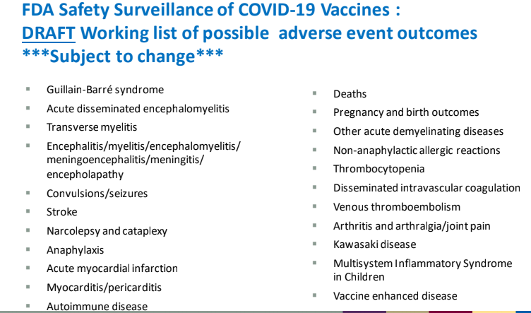

- The reporting systems are recording significant adverse reactions, including the above.

- The New Zealand Government has granted Pfizer and BioNTech indemnity from any claims that may arise from the mRNA Injection use.

- It is unclear whether a private insurance company or ACC will cover a person who suffers a serious injury or death from the mRNA Injection.

- There is no compensation program in New Zealand.

- The New Zealand Ministry of Health Covid Committee discussed the issue of compensation in one of their webinars. The facilitator made the following comment:
“There were a couple of questions at the last meeting that came through so I'm just going to run those off quickly.

The first was around funding to support primary care when people are presenting to them with side effects following their vaccination.

There is no specific funding available to cover that and no specific funding to cover the submission of an adverse event into CARM so there isn't any funding to cover that.

I'm going to touch base, I spoke to the post-event team leader today just to follow up with him and he's organising for me the contacts at ACC so we can understand what is the threshold at which we can make a claim through ACC that this is a treatment injury.

I haven't seen those yet, but we will follow that up and see where it takes us.”

Q16: Will you compensate my family if I die from an adverse reaction from the mRNA Vaccine? If I accept your direction to take the mRNA Injection, will you accept personally liable for my death as a consequence of administration of the mRNA Injection, irrespective of any claim to be carrying out instructions? If you will not accept personal liability, why not?

- According to projections by UK's top modelling agency, Statement from the Scientific Pandemic Influenza Group on Modelling, Operational sub-group (SPI-M-O), the third wave of COVID spike will hospitalise and kill 60 to 70% of those people who took both the mRNA Injection doses.

- You can access the above Statement by clicking on the link below:
S1182_SPI-M-O_Summary_of_modelling_of_easing_roadmap_step_2_restrictions.pdf (publishing.service.gov.uk)
or going via the Gov.UK website:
SPI-M-O: Summary of further modelling of easing restrictions – Roadmap Step 2, 31 March 2021 - GOV.UK (www.gov.uk)

- In 'The Safety of COVID-19 Vaccinations—We Should Rethink the Policy' in MPDI, the experts compared the risks and benefits of the mRNA Injection, given that the COVID-19 vaccines have had expedited reviews without sufficient safety data. They calculated the number needed to vaccinate (NNTV) from a sizeable Israeli field study to prevent one death. The results showed that:

"The NNTV is between 200–700 to prevent one case of COVID-19 for the mRNA vaccine marketed by Pfizer, while the NNTV to prevent one death is between 9000 and 50,000 (95% confidence interval), with 16,000 as a point estimate. The number of cases experiencing adverse reactions has been reported to be 700 per 100,000 vaccinations. Currently, we see 16 serious side effects per 100,000 vaccinations, and the number of fatal side effects is at 4.11/100,000 vaccinations. For three deaths prevented by vaccination, we have to accept two inflicted by vaccination. Conclusions: This lack of clear benefit should cause governments to rethink their vaccination policy."

- Why are we trusting a company that has a record of acting unlawfully? According to the Violation Tracker Parent Company Summary , Pfizer has incurred $4,660,896,333 in penalties since 2000.

Q17: Are you legally able to ask about my private information concerning whether I have received the mRNA Injection or not?

- The MOH states on its website:
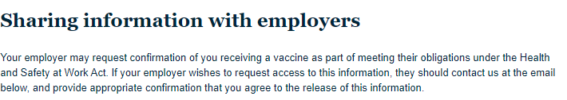

- Please note that I do not under any circumstances agree to the release of this information.

Conclusion
- Given the above information (which is only a summary of my concerns) and the pressure from you to take an experimental mRNA Injection which is part of a clinical trial and has not been given full consent, I am suffering emotional distress and feel that I am being bullied and discriminated against.

- I did not agree to you having control of what substances are injected into my body when we agreed to the conditions of my employment. I am now faced with being disadvantaged by your unjustified actions to have control over my body.

- I also believe you have contravened section 92 of the Health and Safety at Work Act 2015, which prohibits coercion or inducement.

- Please let me know if you would like to discuss this information further. I would prefer not to go down the litigation path as I hope we can sort out this misunderstanding and continue in a mutually beneficial employment relationship. If, however, this does proceed to the Employment Relations Tribunal, please remember that the burden of proof falls on the employer to prove that the mRNA Injection is necessary to the continuation of the employer's business.

Yours sincerely

Your name

https://www.pfizer.com/news/hot-topics/the_facts_about_pfizer_and_biontech_s_covid_19_vaccine
COVID-19 Therapeutic Products – Questions and Answers (medsafe.govt.nz)
http://labeling.pfizer.com/ShowLabeling.aspx?id=14472&format=pdf
https://www.merck.com/news/merck-discontinues-development-of-sars-cov-2-covid-19-vaccine-candidates-continues-development-of-two-investigational-therapeutic-candidates/
https://finance.yahoo.com/news/fauci-vaccines-will-only-prevent-symptoms-not-block-the-virus-195051568.html
https://www.bmj.com/content/bmj/371/bmj.m4037.full.pdf
https://www.clinicaltrials.gov/ct2/show/NCT04848584?cond=pfizer+vaccine&draw=2&rank=1
https://www.researchgate.net/publication/346464618_Informed_consent_disclosure_to_vaccine_trial_subjects_of_risk_of_COVID-19_vaccines_worsening_clinical_disease/fulltext/5fc3873e458515b79784d097/Informed-consent-disclosure-to-vaccine-trial-subjects-of-risk-of-COVID-19-vaccines-worsening-clinical-disease.pdf?origin=publication_detail
https://med.nyu.edu/faculty/timothy-j-cardozo
https://medicine.tulane.edu/departments/pathology-laboratory-medicine-division-comparative-pathology/faculty/ronald-s-veazey-dvm
https://www.medsafe.govt.nz/COVID-19/status-of-applications.asp
https://www.businessinsider.com.au/pfizer-biontech-vaccine-designed-in-hours-one-weekend-2020-12?r=US&IR=T
https://www.reuters.com/article/us-health-coronavirus-vaccines-insight-idUSKBN20Y1GZ
Comirnaty-RMP.pdf (medsafe.govt.nz)
White Paper on Experimental Vaccines for Covid-19* (wsimg.com)
As pressure for coronavirus vaccine mounts, scientists debate risks of accelerated testing | Reuters
As pressure for coronavirus vaccine mounts, scientists debate risks of accelerated testing | Reuters
Preliminary Findings of mRNA Covid-19 Vaccine Safety in Pregnant Persons | NEJM
https://www.cdc.gov/coronavirus/2019-ncov/vaccines/recommendations/pregnancy.html
Open Letter to the WHO: Immediately Halt All Covid-19 Mass Vaccinations-Geert Vanden Bossche, DMV, PhD – Freedom Of Speech (fos-sa.org)
https://planetes360.fr/pr-luc-montagnier-les-variants-viennent-des-vaccinations/ and https://planetes360.fr/pr-luc-montagnier-les-variants-viennent-des-vaccinations/
https://www.pfizer.com/news/hot-topics/the_facts_about_pfizer_and_biontech_s_covid_19_vaccine
https://www.youtube.com/watch?v=aMB1dRJNHe8
https://www.rwmalonemd.com/
https://www.lifesitenews.com/news/vaccine-researcher-admits-big-mistake-says-spike-protein-is-dangerous-toxin
https://www.bmj.com/content/371/bmj.m4347/rr-6
Dr. Peter McCullough on with Reiner Fuelmich June 11, 2021 (bitchute.com)
https://www.youtube.com/watch?v=QAHi3lX3oGM
https://journals.lww.com/americantherapeutics/Abstract/9000/Ivermectin_for_Prevention_and_Treatment_of.98040.aspx
https://www.fda.gov/media/143557/download
https://www.rnz.co.nz/news/national/435107/government-grants-vaccine-suppliers-indemnity-against-claims
https://youtu.be/hIyyJ6s0oRM
SPI-M-O: Summary of further modelling of easing restrictions – Roadmap Step 2, 31 March 2021 - GOV.UK (www.gov.uk)
Vaccines | Free Full-Text | The Safety of COVID-19 Vaccinations—We Should Rethink the Policy | HTML (mdpi.com)
https://violationtracker.goodjobsfirst.org/parent/pfizer

